EXPERIMENT 5
IMPLEMENTION OF PLAYFAIR CIPHER

Aim:
To implement the Playfair Cipher substitution technique using Python.

Algorithm:
• Read the plaintext and keyword.
• Generate the 5×5 key matrix.
• Split the text into pairs.
• Apply Playfair rules.
• Encrypt the text.
• Display the encrypted text.

Code:
key = input("Enter Key: ").upper().replace(" ", "")
plaintext = input("Enter Plain Text: ").upper().replace(" ", "")
matrix = []
used = []
for ch in key:
if ch == 'J':
ch = 'I'
if ch not in used and ch.isalpha():
used.append(ch)
matrix.append(ch)
for ch in "ABCDEFGHIKLMNOPQRSTUVWXYZ":
if ch not in used:
used.append(ch)
matrix.append(ch)
table = [matrix[i:i+5] for i in range(0, 25, 5)]
def find(ch):
if ch == 'J':
ch = 'I'
for i in range(5):
for j in range(5):
if table[i][j] == ch:
return i, j
text = ""
i = 0
while i < len(plaintext):
a = plaintext[i]
if a == 'J':
a = 'I'
if i + 1 < len(plaintext):
b = plaintext[i + 1]
if b == 'J':
b = 'I'
if a == b:
text += a + "X"
i += 1
else:
text += a + b
i += 2
else:
text += a + "X"
i += 1
encrypted = ""
for i in range(0, len(text), 2):
a = text[i]
b = text[i + 1]
r1, c1 = find(a)
r2, c2 = find(b)
if r1 == r2:
encrypted += table[r1][(c1 + 1) % 5]
encrypted += table[r2][(c2 + 1) % 5]
elif c1 == c2:
encrypted += table[(r1 + 1) % 5][c1]
encrypted += table[(r2 + 1) % 5][c2]
else:
encrypted += table[r1][c2]
encrypted += table[r2][c1]
decrypted = ""
for i in range(0, len(encrypted), 2):
a = encrypted[i]
b = encrypted[i + 1]
r1, c1 = find(a)
r2, c2 = find(b)
if r1 == r2:
decrypted += table[r1][(c1 - 1) % 5]
decrypted += table[r2][(c2 - 1) % 5]
elif c1 == c2:
decrypted += table[(r1 - 1) % 5][c1]
decrypted += table[(r2 - 1) % 5][c2]
else:
decrypted += table[r1][c2]
decrypted += table[r2][c1]
print("Encrypted Text:", encrypted)
print("Decrypted Text:", decrypted)

Output:
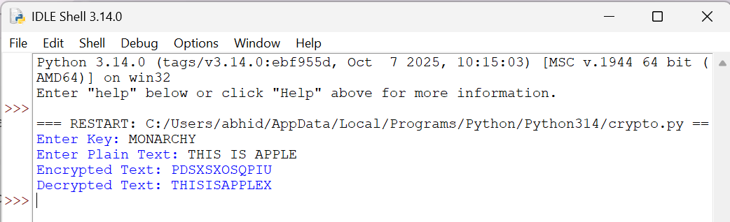

Result:
Thus, the Playfair Cipher substitution technique was implemented
successfully using Python

